

International School

Capstone Project 2
CMU-SE 451

Database Design
Version 1.3
Date: May 11, 2026

SEIMS - Smart Expiry Product Integration & Management System

Created by C2SE.15
Nguyen Huy Hoang Bao - 28219004148
Nguyen Pham Nhat Huy - 28211100686
Pham Minh Trang - 28204632177
Duong Quoc Binh – 28219006390
Nguyen Huu Thang – 28211102537

Database Design Review Panel Representative:

Name Signature Date
Capstone Project 2 - Mentor:

Name MSc.Truong Dinh Huy Signature Date

PROJECT INFORMATION

Project acronym | SEIMS
Project Title | Smart Expiry Product Integration & Management System
Start Date | March 6, 2026 | End Date |  | May 11, 2026
Lead Institution | International School, Duy Tan University
Project Mentor | MSc.Truong Dinh Huy  Email: huy.truongdinh@gmail.com  Tel: 0982132352
Scrum master / Project Leader & contact details | Pham Minh Trang  Email: pmtrang04@gmail.com  Tel: 0911855450
Partner Organization | Duy Tan University
Team members | Name |  | Email |  | Tel
28219004148 | Nguyen Huy Hoang Bao |  | bao91ndu1819@gmail.com |  | 0385092839
28211100686 | Nguyen Pham Nhat Huy |  | huy785619@gmail.com |  | 0395546300
28204632177 | Pham Minh Trang |  | pmtrang04@gmail.com |  | 0911855450
28219006390 | Duong Quoc Binh |  | duongquocbinh@dtu.edu.vn |  | 0932033856
28211102537 | Nguyen Huu Thang |  | nguyenhuuthang11@dtu.edu.vn |  | 0702377702

DOCUMENT APPROVALS
The following signatures are required for approval of this document.
MSc.Truong Dinh Huy  Mentor | Signature | Date
Nguyen Huy Hoang Bao  Student ID: 28219004148  Team Member | Signature | Date
Nguyen Pham Nhat Huy  Student ID: 28211100686  Team Member | Signature | Date
Pham Minh Trang  Student ID: 28204632177  Project Leader | Signature | Date
Duong Quoc Binh  Student ID: 28219006390  Team Member | Signature | Date
Nguyen Huu Thang  Student ID: 28211102537  Team Member | Signature | Date

DOCUMENT NAME

Document Title | Database Design
Author(s) | Nguyen Huy Hoang Bao, Nguyen Pham Nhat Huy
Role | Team Member
Date | May 11,2026 | File name: | 6 C2SE.15_DatabaseDesign_Ver1.3.doc

REVISION HISTORY
Version | Date | Comments | Author | Approval
1.0 | March 6, 2026 | Create Document | Bao
1.1 | March 27, 2026 | Update Document | Bao
1.2 | April 17, 2026 | Update Document | Bao
1.3 | May 11, 2026 | Official Document | Huy

Table of Contents
1. Introduction 1
1.1. Purpose 1
1.2. Document objectives 1
1.3. Intended audience 1
1.4. Scope, approach and methods 2
1.5. System overview 2
2. System Overview 2
2.1. Database management system configurations 2
2.2. Database software utilities 2
3. Database-Wide Design Decisions 2
3.1. Key factors influencing design. 2
3.2. Performance and availability decisions 3
4. Database Administrative Functions 3
4.1. Responsibility 3
4.2. Entity Relationship Diagram 4
4.3. Entity References Diagram 5
4.3. Database Identification 6
5. References 23

1. Introduction
The Database Design maps the logical data model of the Supermarket Emergency Inventory Management System (SEIMS) to the target MySQL database management system, considering the system’s performance and data integrity requirements.

1.1. Purpose
The purpose of this Database Design is to ensure that every transaction—from inventory tracking and expiry alerts to charity distribution—meets or exceeds performance requirements. This document considers the high volume of daily supermarket transactions and the real-time needs of charity requests to produce a robust schema.

1.2. Document objectives
The objectives of this document are:
- To describe the design of the seims_db database, a collection of related tables (users, inventory, donations) accessible via a DBMS.
- To serve as a technical blueprint for implementing the database and related backend software units.
- To provide stakeholders and developers with visibility into the data architecture necessary for software development.

1.3. Intended audience
This document is intended for:
- Technical Developers: To evaluate the quality and logic of the data structures.
- Architects: To ensure the overall system architecture aligns with the database schema.
- Designers & Developers: To implement software logic that interacts with these tables.
- Quality Assurance (QA): To create test cases that validate data integrity and referential constraints.

1.4. Scope, approach and methods
The SEIMS database design defines all objects by mapping system entities (Supermarkets, Inventory Lots, Charity Organizations) into relational tables. Logical relationships are strictly implemented using Foreign Keys, ensuring that a donation request cannot exist without a valid inventory lot or a registered charity user.

1.5. System overview
Table 1. System overview
System Overview | Details
System Name | SEIMS – Supermarket Emergency Inventory Management System
System type | Web
Operational status | In development

2. System Overview

2.1. Database management system configurations
- Database: MySQL
- System: Windows 11

2.2. Database software utilities
Table 2. Database software utilities
Vendor | Product | Version | Comments
MySQL | Workbench | 8.0.42 | Workbench is a visual tool for database architects, developers, and DBAs. It allows for data modeling, SQL development, and database management.

3. Database-Wide Design Decisions

3.1. Key factors influencing design.
- Independence: The database is designed to function independently of the frontend and backend development cycles.
- Standardization: The design follows 3rd Normal Form (3NF) to minimize data redundancy and prevent anomalies in stock levels.
- Expiry Management: The schema prioritizes the expiry_date attribute to facilitate the primary "First-Expire, First-Out" (FEFO) logic.

3.2. Performance and availability decisions
- Indexing: Strategic indexes are placed on expiry_date in the inventory_lots table and status in the orders table to accelerate query performance.
- Integrity: Using ENGINE=InnoDB ensures ACID compliance, which is critical for financial transactions and inventory updates.
- JSON Support: Utilizes MySQL's native JSON data type for audit_logs to store flexible "old" and "new" value snapshots without bloating the schema.

4. Database Administrative Functions

4.1. Responsibility
Table 3. Responsibility
Role | Name | Responsibility
Database Administrator | All Members | Implement and manage the database.

4.2. Entity Relationship Diagram
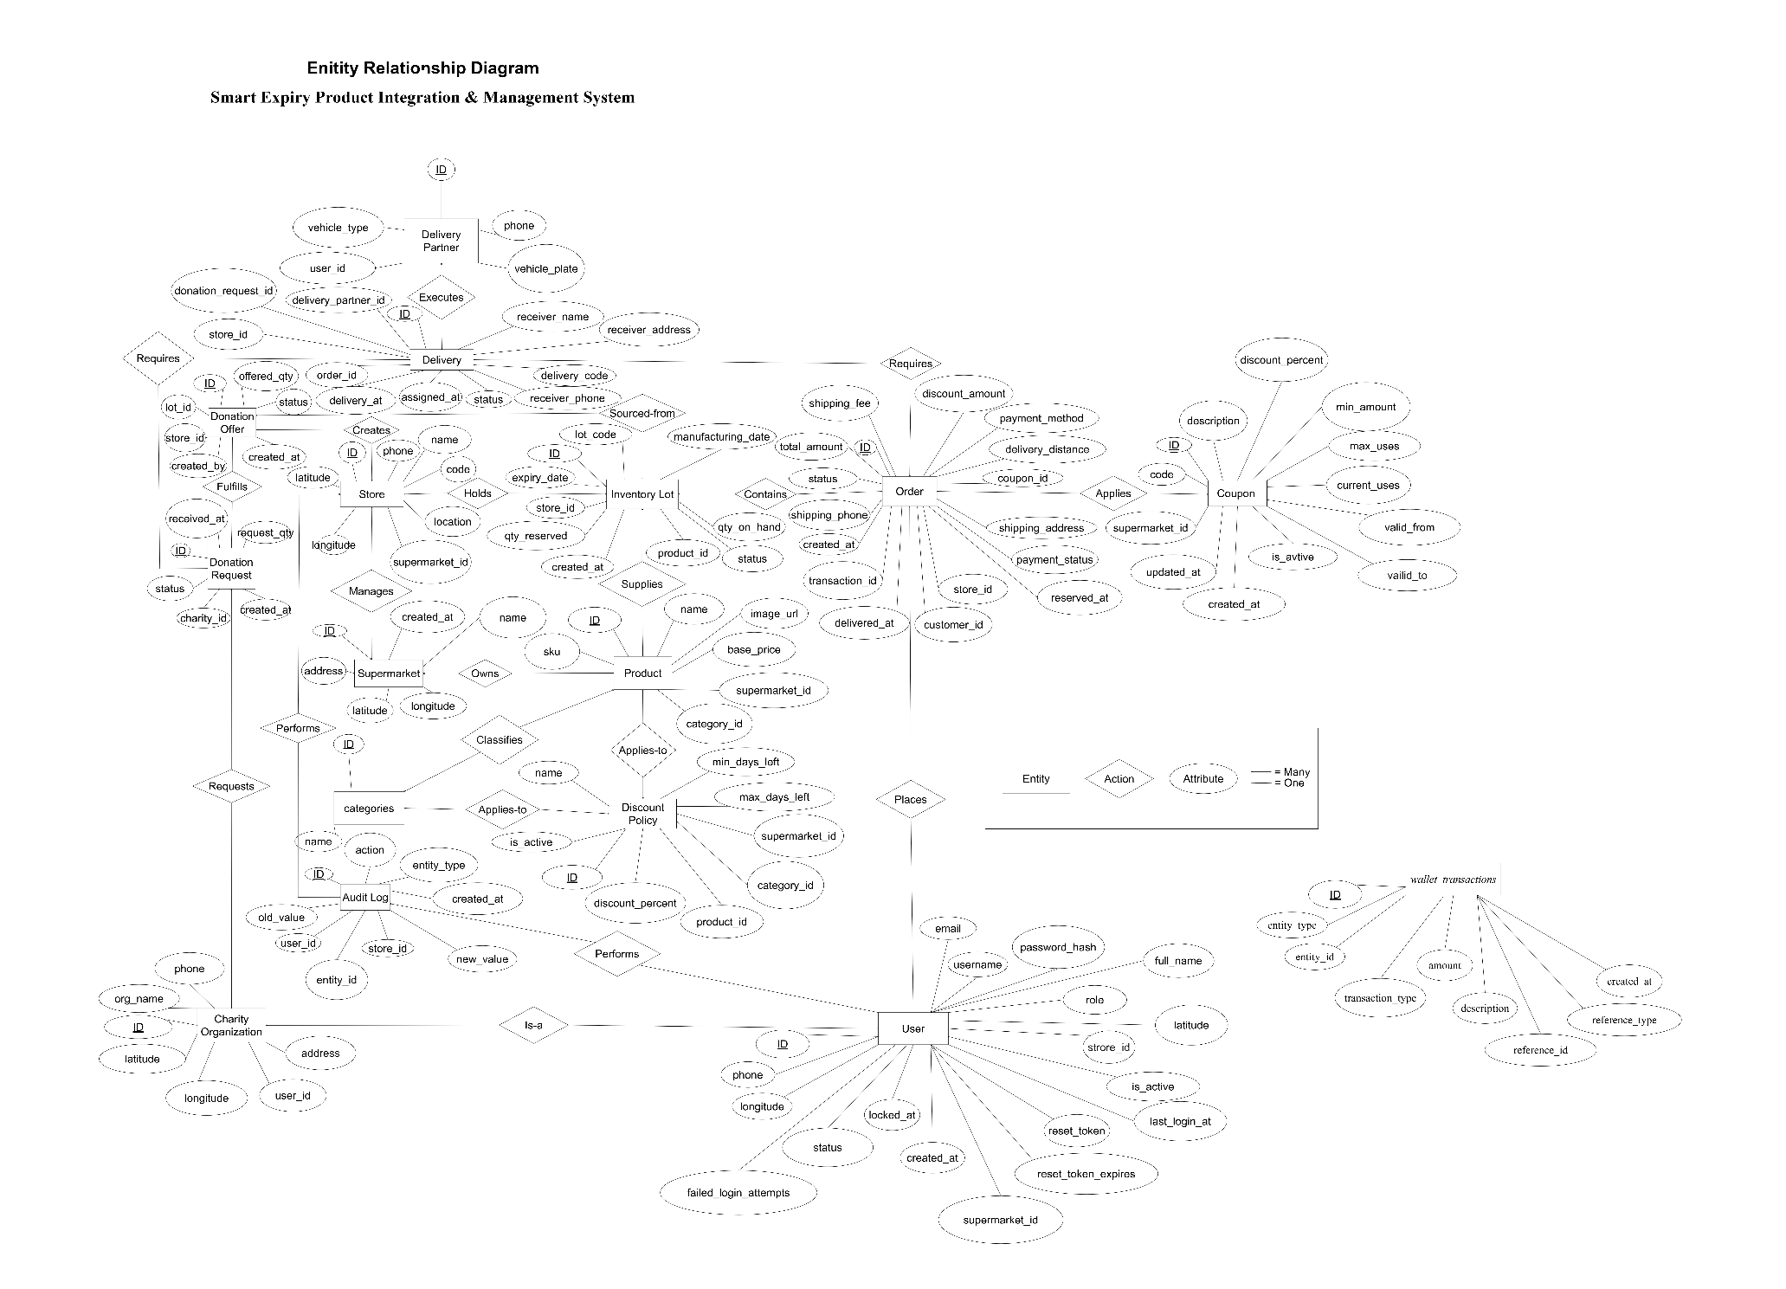
Figure 1: Entity Relationship Diagram

4.3. Entity References Diagram
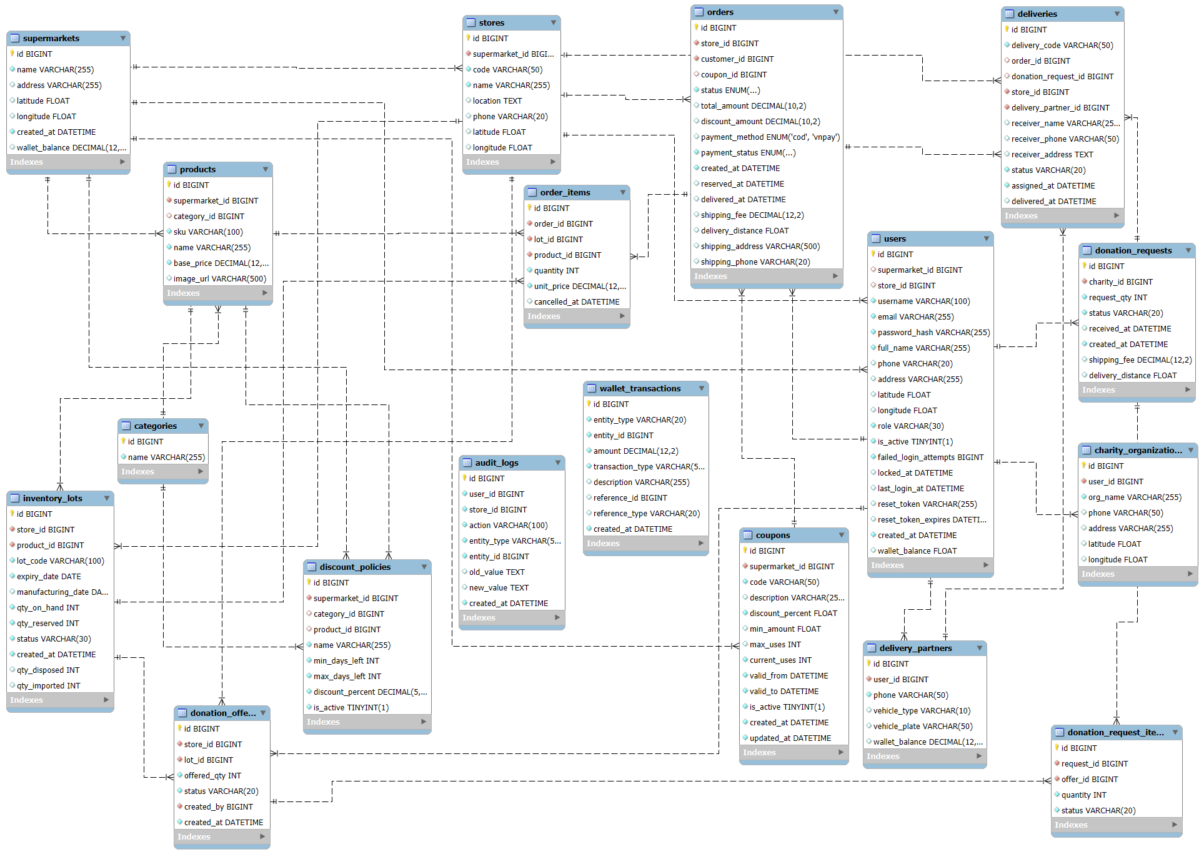
Figure 2: Entity References Diagram

4.3. Database Identification
4.3.1. supermarkets
Table 4. Supermarkets
Field | Type | Constraint | Nullable | Description
id | BIGINT | PRIMARY KEY, AUTO_INCREMENT | No | Unique identifier for each supermarket chain
name | VARCHAR(255) |  | No | Official name of the supermarket
address | VARCHAR(255) |  | Yes | Physical headquarters address
created_at | DATETIME | DEFAULT CURRENT_TIMESTAMP | No | Timestamp of record creation
latitude | FLOAT |  | Yes | Geographic latitude for mapping and location-based services
longitude | FLOAT |  | Yes | Geographic longitude for mapping and location-based services
wallet_balance | DECIMAL(12,2) |  | Yes | Current wallet balance of supermarket

4.3.2. categories
Table 5. Categories
Field | Type | Constraint | Nullable | Description
id | BIGINT | PRIMARY KEY, AUTO_INCREMENT | No | Unique identifier for product category
name | VARCHAR(255) |  | No | Category name used to classify products

4.3.3. stores
Table 6. Stores
Field | Type | Constraint | Nullable | Description
id | BIGINT | PRIMARY KEY, AUTO_INCREMENT | No | Unique identifier for each store branch
supermarket_id | BIGINT | FOREIGN KEY → supermarkets(id), ON DELETE CASCADE | No | Reference to parent supermarket chain
code | VARCHAR(50) | UNIQUE | No | Internal store code used for identification within a supermarket
name | VARCHAR(255) |  | No | Store branch name displayed to users
location | TEXT |  | Yes | Physical address of the store branch
latitude | FLOAT |  | Yes | Latitude coordinate for location-based filtering
longitude | FLOAT |  | Yes | Longitude coordinate for location-based filtering
phone | VARCHAR(20) |  | Yes | Store contact phone number

4.3.4. users
Table 7. Users
Field | Type | Constraint | Nullable | Description
id | BIGINT | PRIMARY KEY, AUTO_INCREMENT | No | Unique identifier for each user in the system
supermarket_id | BIGINT | FOREIGN KEY → supermarkets(id), ON DELETE SET NULL | Yes | Associated supermarket chain (used for admin-level users)
store_id | BIGINT | FOREIGN KEY → stores(id), ON DELETE SET NULL | Yes | Associated store branch (used for store staff)
username | VARCHAR(100) | UNIQUE | No | Unique username used for authentication
email | VARCHAR(255) | UNIQUE | No | Email address used for login and communication
password_hash | VARCHAR(255) |  | No | Securely hashed password for authentication
full_name | VARCHAR(255) |  | No | Full name of the user
phone | VARCHAR(20) | UNIQUE | Yes | Contact phone number
address | VARCHAR(255) |  | Yes | User address used for delivery or identification
latitude | FLOAT |  | Yes | Geographic latitude for location-based services
longitude | FLOAT |  | Yes | Geographic longitude for location-based services
role | ENUM('ADMIN','STAFF','CUSTOMER','CHARITY','DELIVERY') |  | No | Role defining access level and permissions in the system
is_active | BOOLEAN | DEFAULT 1 | No | Indicates whether the account is active or disabled
failed_login_attempts | INT | DEFAULT 0 | No | Number of consecutive failed login attempts for security monitoring
locked_at | DATETIME |  | Yes | Timestamp when the account was locked due to too many failed attempts
last_login_at | DATETIME |  | Yes | Timestamp of the last successful login
reset_token | VARCHAR(255) |  | Yes | Token used for password reset functionality
reset_token_expires | DATETIME |  | Yes | Expiration time of the reset token
created_at | DATETIME | DEFAULT CURRENT_TIMESTAMP | No | Timestamp when the user account was created
wallet_balance | DECIMAL(12,2) |  | Yes | Current wallet balance of user

4.3.5. products
Table 8. Products
Field | Type | Constraint | Nullable | Description
id | BIGINT | PRIMARY KEY | No | Unique identifier for product
supermarket_id | BIGINT | FOREIGN KEY → supermarkets(id), CASCADE | No | Supermarket that owns the product catalog
category_id | BIGINT | FOREIGN KEY → categories(id) | Yes | Category classification of the product
sku | VARCHAR(100) | UNIQUE | No | Stock Keeping Unit (unique per supermarket)
name | VARCHAR(255) |  | No | Product name
base_price | DECIMAL(12,2) |  | No | Original price before discount
image_url | VARCHAR(500) |  | Yes | URL of product image

4.3.6. inventory_lots
Table 9. Inventory_lots
Field | Type | Constraint | Nullable | Description
id | BIGINT | PRIMARY KEY | No | Unique identifier for inventory lot
store_id | BIGINT | FOREIGN KEY → stores(id), CASCADE | No | Store holding the inventory
product_id | BIGINT | FOREIGN KEY → products(id) | No | Product associated with the lot
lot_code | VARCHAR(100) | UNIQUE | No | Batch code for tracking
expiry_date | DATE |  | No | Expiration date of products
manufacturing_date | DATE |  | Yes | Manufacturing date
qty_on_hand | INT |  | No | Current available quantity
qty_reserved | INT |  | No | Quantity reserved for orders
status | VARCHAR(30) |  | No | Status of lot (active, expired, near expiry)
created_at | DATETIME | DEFAULT CURRENT_TIMESTAMP | No | Record creation timestamp
qty_disposed | INT |  | Yes | Quantity disposed due to expiry or damage
qty_imported | INT |  | Yes | Original imported quantity

4.3.7. orders
Table 10. Orders
Field | Type | Constraint | Nullable | Description
id | BIGINT | PRIMARY KEY | No | Unique identifier for order
store_id | BIGINT | FOREIGN KEY → stores(id) | No | Store processing the order
customer_id | BIGINT | FOREIGN KEY → users(id) | No | Customer who placed the order
status | ENUM |  | No | Order lifecycle status
total_amount | DECIMAL(10,2) |  | Yes | Total cost of the order
payment_method | ENUM('cod','vnpay') |  | Yes | Payment method (COD, VNPAY.)
payment_status | ENUM('pending','paid') |  | No | Payment status
created_at | DATETIME | DEFAULT CURRENT_TIMESTAMP | No | Order creation time
reserved_at | DATETIME |  | Yes | Time when items were reserved
delivered_at | DATETIME |  | Yes | Delivery completion time
shipping_address | VARCHAR(500) |  | Yes | Delivery address
coupon_id | BIGINT |  | Yes | Applied coupon
discount_amount | DECIMAL(10,2) |  | Yes | Discount value applied
shipping_phone | VARCHAR(20) |  | Yes | Receiver contact
shipping_fee | DECIMAL(10,2) |  | Yes | Delivery fee
delivery_distance | FLOAT |  | Yes | Delivery distance in kilometers

4.3.8. order_items
Table 11. Order_items
Field | Type | Constraint | Nullable | Description
id | BIGINT | PRIMARY KEY | No | Unique identifier for order item
order_id | BIGINT | FOREIGN KEY → orders(id), CASCADE | No | Parent order
lot_id | BIGINT | FOREIGN KEY → inventory_lots(id) | No | Inventory lot used
product_id | BIGINT | FOREIGN KEY → products(id) | No | Product purchased
quantity | INT |  | No | Quantity of product ordered
unit_price | DECIMAL(12,2) |  | No | Price per unit at purchase time

4.3.9. coupons
Table 12. Coupons
Field | Type | Constraint | Nullable | Description
id | BIGINT | PRIMARY KEY AUTO_INCREMENT | No | Unique identifier for each coupon in the system
supermarket_id | BIGINT | FOREIGN KEY → supermarkets(id), ON DELETE CASCADE | No | The supermarket that issues the coupon, ensuring coupon belongs to a valid business entity
code | VARCHAR(50) | UNIQUE | No | Unique coupon code entered by customers during checkout
description | VARCHAR(255) |  | Yes | Description of the promotion campaign for marketing purposes
discount_percent | FLOAT |  | No | Percentage discount applied to the order total
min_amount | FLOAT |  | Yes | Minimum order value required to apply this coupon
max_uses | INT |  | Yes | Maximum number of times the coupon can be used globally
current_uses | INT |  | No | Tracks how many times the coupon has already been used
valid_from | DATETIME |  | No | Start time from which the coupon is valid
valid_to | DATETIME |  | No | Expiration time after which the coupon is no longer usable
is_active | TINYINT(1) |  | No | Indicates whether the coupon is currently active or disabled
created_at | DATETIME |  | No | Timestamp when the coupon was created
updated_at | DATETIME |  | No | Timestamp when the coupon was last updated

4.3.10. discount_policies
Table 13. Discount_policies
Field | Type | Constraint | Nullable | Description
id | BIGINT | PRIMARY KEY, AUTO_INCREMENT | No | Unique identifier for each discount policy
supermarket_id | BIGINT | FOREIGN KEY → supermarkets(id), ON DELETE CASCADE | No | Supermarket that defines and owns the discount policy
category_id | BIGINT | FOREIGN KEY → categories(id), ON DELETE CASCADE | Yes | Applies discount to a specific category if defined
product_id | BIGINT | FOREIGN KEY → products(id), ON DELETE CASCADE | Yes | Applies discount to a specific product if defined
name | VARCHAR(255) |  | No | Name of the discount policy for management and reporting
min_days_left | INT |  | No | Minimum number of days before expiry to trigger discount
max_days_left | INT |  | No | Maximum number of days before expiry
discount_percent | DECIMAL(5,2) |  | No | Discount percentage applied to products
is_active | TINYINT(1) |  | No | Indicates whether the policy is currently active

4.3.11. delivery_partners
Table 14. Delivery_partners
Field | Type | Constraint | Nullable | Description
id | BIGINT | PRIMARY KEY, AUTO_INCREMENT | No | Unique identifier for each delivery partner
user_id | BIGINT | FOREIGN KEY → users(id), ON DELETE CASCADE, UNIQUE | No | Links to a user account representing the delivery personnel
phone | VARCHAR(50) |  | No | Contact number of the delivery partner
vehicle_type | VARCHAR(10) |  | Yes | Type of vehicle used for delivery (bike, car, etc.)
vehicle_plate | VARCHAR(50) |  | Yes | Vehicle registration plate for identification
wallet_balance | DECIMAL(12,2) |  | Yes | Current wallet balance of delivery partner
4.3.12. donation_requests
Table 16. Donation_requests
Field | Type | Constraint | Nullable | Description
id | BIGINT | PRIMARY KEY, AUTO_INCREMENT | No | Unique identifier for donation request
charity_id | BIGINT | FOREIGN KEY → users(id) | No | User account representing charity organization
request_qty | INT |  | No | Total quantity requested by the charity
status | VARCHAR(20) |  | No | Status of request (pending, approved, completed)
received_at | DATETIME |  | Yes | Timestamp when donation was received
created_at | DATETIME | DEFAULT CURRENT_TIMESTAMP | No | Timestamp when request was created
shipping_fee | DECIMAL(12,2) |  | Yes | Shipping fee for donation delivery
delivery_distance | FLOAT |  | Yes | Delivery distance in kilometers

4.3.13. donation_offers
Table 15. Donation_offers
Field | Type | Constraint | Nullable | Description
id | BIGINT | PRIMARY KEY, AUTO_INCREMENT | No | Unique identifier for donation offer
store_id | BIGINT | FOREIGN KEY → stores(id) | No | Store that offers the donation
lot_id | BIGINT | FOREIGN KEY → inventory_lots(id) | No | Inventory batch being donated
offered_qty | INT |  | No | Quantity offered for donation
status | VARCHAR(20) |  | No | Status (pending, accepted, rejected)
created_by | BIGINT | FOREIGN KEY → users(id) | No | User who created the offer
created_at | DATETIME | DEFAULT CURRENT_TIMESTAMP | No | Creation timestamp

4.3.14. donation_requests_items
Table 17. Donation_request_items
Field | Type | Constraint | Nullable | Description
id | BIGINT | PRIMARY KEY, AUTO_INCREMENT | No | Unique identifier for each allocation record
request_id | BIGINT | FOREIGN KEY → donation_requests(id), ON DELETE CASCADE | No | Donation request being fulfilled
offer_id | BIGINT | FOREIGN KEY → donation_offers(id) | No | Donation offer used
quantity | INT |  | No | Quantity accepted from the offer
status | VARCHAR(20) |  | No | Allocation status

4.3.15. deliveries
Table 18. Deliveries
Field | Type | Constraint | Nullable | Description
id | BIGINT | PRIMARY KEY, AUTO_INCREMENT | No | Unique identifier for delivery
delivery_code | VARCHAR(50) | UNIQUE | No | Unique tracking code for delivery
order_id | BIGINT | FOREIGN KEY → orders(id), ON DELETE CASCADE | Yes | Related order if delivery is for purchase
donation_request_id | BIGINT | FOREIGN KEY → donation_requests(id), ON DELETE CASCADE | Yes | Related donation delivery
store_id | BIGINT | FOREIGN KEY → stores(id) | No | Store dispatching the goods
delivery_partner_id | BIGINT | FOREIGN KEY → delivery_partners(id) | No | Assigned delivery partner
receiver_name | VARCHAR(255) |  | Yes | Name of receiver
receiver_phone | VARCHAR(50) |  | Yes | Receiver contact
receiver_address | TEXT |  | Yes | Delivery location
status | VARCHAR(20) |  | No | Delivery status (assigned, delivering, completed)
assigned_at | DATETIME | DEFAULT CURRENT_TIMESTAMP | No | Assignment time
delivered_at | DATETIME |  | Yes | Completion time

4.3.16. charity_organizations
Table 19. Charity_organizations
Field | Type | Constraint | Nullable | Description
id | BIGINT | PRIMARY KEY, AUTO_INCREMENT | No | Unique identifier for charity organization
user_id | BIGINT | UNIQUE, FOREIGN KEY → users(id), ON DELETE CASCADE | No | User account representing organization
org_name | VARCHAR(255) |  | No | Official name of charity
phone | VARCHAR(50) |  | Yes | Contact phone
address | VARCHAR(255) |  | Yes | Organization address
latitude | FLOAT |  | Yes | Location for delivery
longitude | FLOAT |  | Yes | Location for delivery

4.3.17. audit_logs
Table 20. Audit_logs
Field | Type | Constraint | Nullable | Description
id | BIGINT | PRIMARY KEY, AUTO_INCREMENT | No | Unique identifier for log record
user_id | BIGINT | FOREIGN KEY → users(id) | No | User performing the action
store_id | BIGINT | FOREIGN KEY → stores(id) | No | Store context
action | VARCHAR(100) |  | No | Action performed (CREATE, UPDATE, DELETE)
entity_type | VARCHAR(50) |  | No | Type of entity affected
entity_id | BIGINT |  | No | ID of affected record
old_value | TEXT |  | Yes | Previous data state
new_value | TEXT |  | Yes | Updated data state
created_at | DATETIME | DEFAULT CURRENT_TIMESTAMP | No | Timestamp of action

4.3.18. wallet_transactions
Table 20. wallet_transactions
Field | Type | Constraint | Nullable | Description
id | BIGINT | PRIMARY KEY, AUTO_INCREMENT | No | Unique identifier for wallet transaction
entity_type | VARCHAR(20) |  | No | Type of entity owning the wallet
entity_id | BIGINT |  | No | ID of related entity
amount | DECIMAL(12,2) |  | No | Transaction amount
transaction_type | VARCHAR(50) |  | No | Type of transaction
description | VARCHAR(255) |  | Yes | Transaction description
reference_id | BIGINT |  | Yes | Related reference ID
reference_type | VARCHAR(20) |  | Yes | Type of reference entity
created_at | DATETIME | DEFAULT CURRENT_TIMESTAMP | No | Transaction creation timestamp

5. References
[1]. MySQL Workbench 8.0 CE
[2]. Entity Relationship Mapping

